Task 3

are **not Java code**. They are formatting marks from my message.

### Do this exactly

1. Press **Ctrl + A** in the HackerRank editor.
2. Delete everything.
3. Paste the code below.
4. **Do not type or paste any ` ``` ` symbols.**

```text
import java.io.*;
import java.util.*;

class Result {
public static List<Integer> compareTriplets(List<Integer> a, List<Integer> b) {
int alice = 0;
int bob = 0;

for (int i = 0; i < 3; i++) {
if (a.get(i) > b.get(i)) {
alice++;
} else if (a.get(i) < b.get(i)) {
bob++;
}
}

return Arrays.asList(alice, bob);
}
}

public class Solution {
public static void main(String[] args) throws IOException {
Scanner sc = new Scanner(System.in);

List<Integer> a = new ArrayList<>();
List<Integer> b = new ArrayList<>();

for (int i = 0; i < 3; i++) {
a.add(sc.nextInt());
}

for (int i = 0; i < 3; i++) {
b.add(sc.nextInt());
}

List<Integer> result = Result.compareTriplets(a, b);

System.out.println(result.get(0) + " " + result.get(1));

sc.close();
}
}
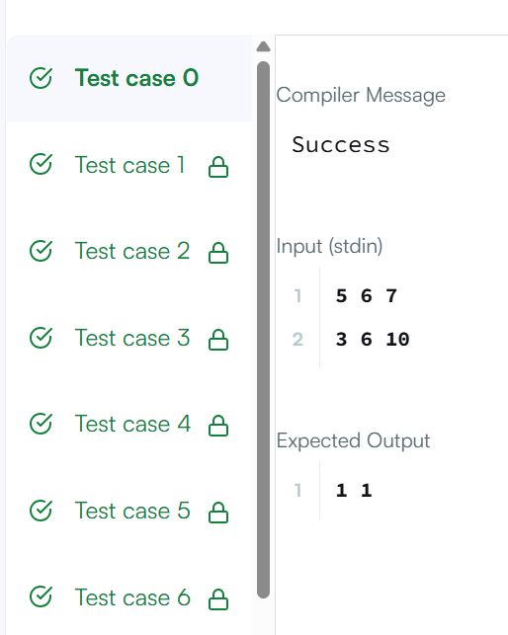
Task 4
Task 4
import java.io.;
import java.util.;
class Result {
public static List<Integer> compareTriplets(List<Integer> a, List<Integer> b) {
int alice = 0;
int bob = 0;

for (int i = 0; i < 3; i++) {
if (a.get(i) > b.get(i)) {
alice++;
} else if (a.get(i) < b.get(i)) {
bob++;
}
}

return Arrays.asList(alice, bob);
}
}
public class Solution {
public static void main(String[] args) throws IOException {
Scanner sc = new Scanner(System.in);

List<Integer> a = new ArrayList<>();
List<Integer> b = new ArrayList<>();

for (int i = 0; i < 3; i++) {
a.add(sc.nextInt());
}

for (int i = 0; i < 3; i++) {
b.add(sc.nextInt());
}

List<Integer> result = Result.compareTriplets(a, b);

System.out.println(result.get(0) + " " + result.get(1));

sc.close();
}
}
